Documents for Experience.
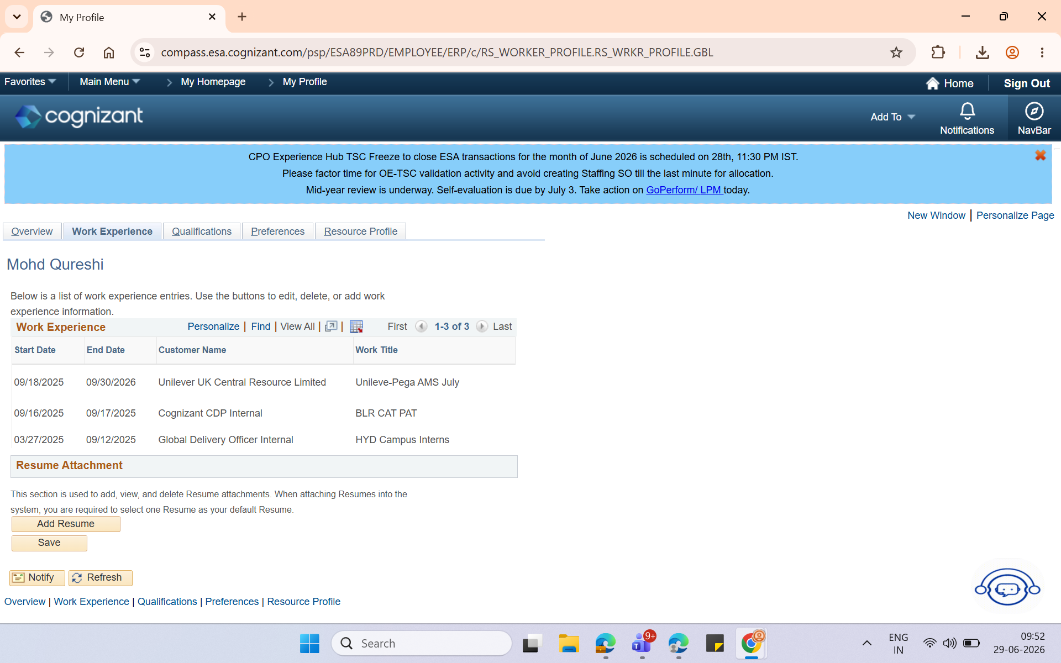
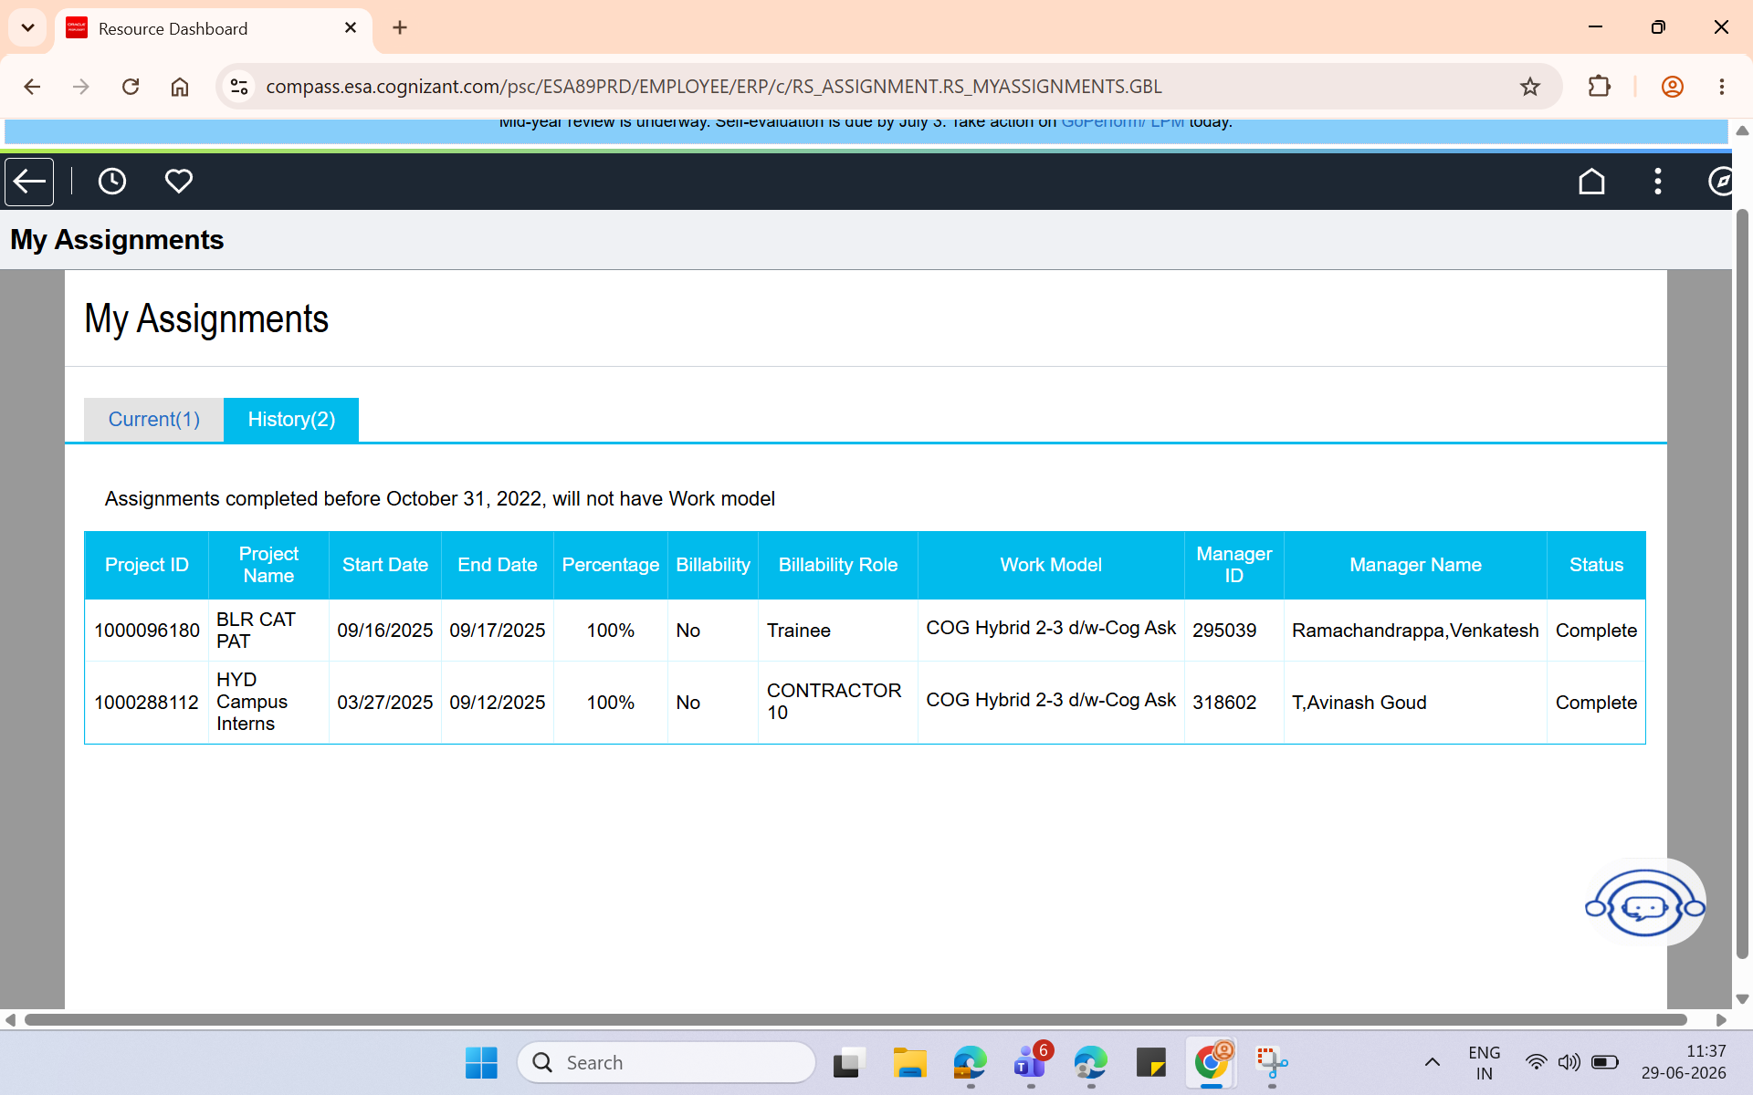
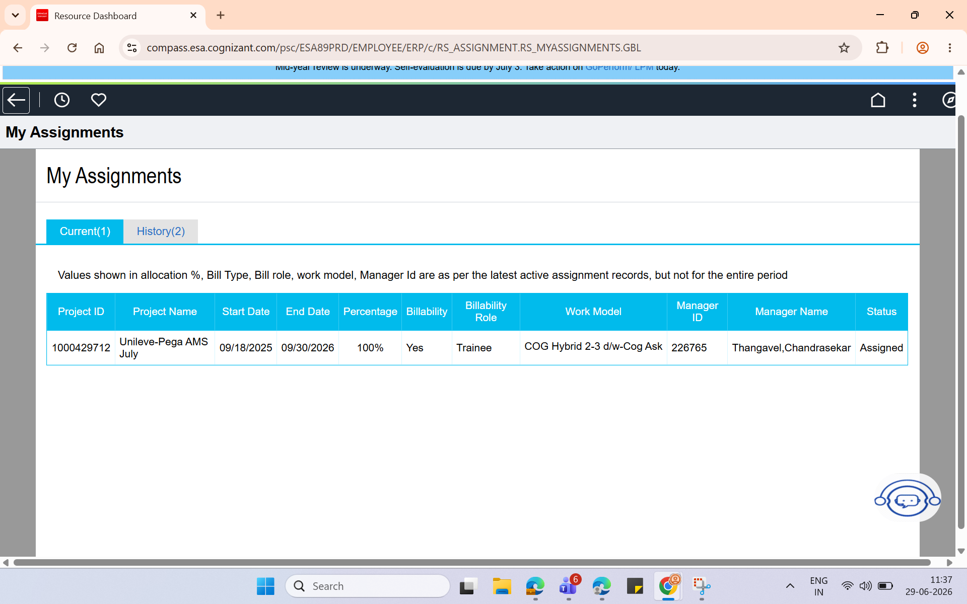

I am Attaching all details of Work That i have done , And also I have applied for Work Experience letter as soon as i get i can provide that as well .!

